# RHPWG Shared Database Subcommittee

Conference Call November 8, 2018

Notes

1. Present: Cindy, Ryan, Roslyn, Kristen, Tina (partial), Pat, Tom, Shawn, Ted
2. Administrative
   1. Current Notes – MT DEQ
   2. Last month’s notes at <https://www.wrapair2.org/RHP_SharedDB.aspx> (bottom of page)
   3. For information: Monitoring and Glideslope Subcommittee Sharefile link: <https://azdeq.sharefile.com/d-sc6c4f002be1402ca>
   4. Updates from other Work Groups and Subcommittees
      1. Brandon talked about NCII numbers in the monitoring subcommittee and how the Trijonis number impacts the glideslope and looking into how those numbers compare to existing data. The Trijonis values may need to be reevaluated and that was seconded by EPA (Brett). EPA will update those values in the spring as part of the Regional Haze Roadmap.
3. Documentation discussion (see attachments)
   1. ***“Sky High Overview”* ... or *“Regional Haze Planning 101”*** – suggest finalization
      * 1. This is an overview that could be helpful for people that are not familiar with the RH planning process.
        2. Is this final enough to go on the TSS? Do we need other approval outside of this workgroup?
           1. Everyone voted it was ready. It will go to the RHPWG to go through the docketing planning process where the chairs will take care of that.
           2. We can make edits to this in the future.
           3. Tom says there is a functional need to get documentation added to the TSS so more users can use it. There is also the goal of getting to the December workplan meeting and we may want to deliver this as final then. There is a set process for a final product to go through the final deliverable. Is this document one of those documents or is this something that would not go through that process. Cindy says this is not directly laid out as a task – we are supposed to have tools for the TSS and document how those tools work.
           4. The December report out could be a power point that would be a deliverable
   2. ***“Tool Completion Protocol”*** – discuss whether this process is appropriate; Is documentation of this overkill?
      1. Anyone using the TSS will know what work is done and what the current status is.
      2. We will provide progress reports for the entire community. Our subcommittee will be ongoing for the next few years while everyone is doing the regional haze planning. That includes the tools being developed and the documentation we need to have for the database. We will have periods where we don’t need to meet twice a month. But once we get emission tools up we will meet more frequently.
      3. Pat says a communication gap exists in getting buy-in from states not participating in the subcommittees. Step 7 should be split into two steps to make sure we have a broader buy-in from all the states.
      4. Checklist comments:
         1. Add a summary field to summarize what the tool is and shows.
         2. Should the document link be outside of the table?
            1. This is intended to allow CIRA to show the response to comment document so it should stay here.
         3. There should be a link to the tool in the main header so that people reviewing this can find it easily.
            1. The links are not expected to change soon.
         4. **ACTION ITEM The checklist will be completed for the two completed tools by Cindy for the next call.**
         5. No objections.
   3. ***FAQs*** – Need more questions (and answers)!
      1. **ACTION ITEM! Each state should write at least one question and one answer by next month’s call.**
      2. Can the questions be from any area?
         1. Yes – this is where we will point people to and might look here to start. We should link to work from other subcommittees if it makes sense.
      3. How detailed are we expecting the questions to be?
         1. Don’t want exactly the same thing but the ability to get to information from multiple places.
      4. Focus on monitoring for now or work the monitoring subcommittee has done. Maybe we can talk about how the emissions inventory work was done? There is lots we can add in.
      5. Think about it as a member of the public trying to figure out what states are doing getting ready for regional haze.
      6. Users that haven’t been involved in the development but need SIPs – what questions might they have? We might have different types of questions so that people can find what they are looking for.
      7. This will likely evolve as we move through the regional analysis process. We can keep adding Q and A as we go along.
      8. We will want to reach out to EPA to see if there are additional questions that they have once they use these tools to review SIP submittals.
   4. ***Minimum functionalities of the TSSv2***
      1. Is this necessary? Do we need to complete this?
      2. CIRA says this is a requirements document and we should fill it out with more information.
      3. The other subcommittees should fill this out but lots of subcommittees don’t have products yet. Bring it up at the December meeting as an expectation on each subcommittee.
      4. Pat will help flesh out this document out.
   5. ***TSS Website Description*** – on hold until we are further along
   6. ***Parameter Mapping Guide*** – for Modeling/EI Subcommittee
   7. We can ask the developers to put together documentation that we will sign off on in 2019 for the TSS description documentation or the glossary.
4. Discussion of charts - explanations
   1. 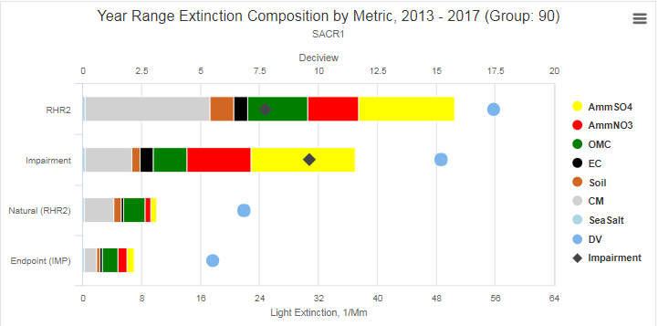

(Making sure we understand what this is telling us; How was the endpoint calculated?) *[Additional question added after meeting: Where do we find the calculation for RHR2?]*

The top row shows a bar chart with the five-year (2013-2017) average of haze components’ light extinction on the 20% haziest (not most impaired) days. Superimposed on that are the total deciviews (blue dot) and the impairment deciviews (black diamond) on the 20% haziest days. For both, these represent a 5-year average, since the date range chosen was 2013-2017. Note that the impairment metric was applied for the haziest days, showing that impairment on the haziest days was much lower than the total haze.

The second row shows the same metrics, except that the days chosen are the 20% most impaired days (not the haziest days). A discussion of why the impairment should increase on the 20% most impaired days (compared to the 20% haziest days) ensued. The discussion focused on the fact that haze on the 20% haziest days is often impacted by “extreme episodic events” (e3); thus, the days chosen (haziest), will have significant reduction in the impairment metric on those days. There are days other than the 20% haziest which show more impairment. These are captured in the 20% most impaired days metric. It should make sense (once we think about it) that impairment will increase on the 20% most impaired days. The key is to separate out the calculations of total haze and impairment from the choice of which days to focus on.

**Question: Will we ever need to know the impairment on the haziest days?**  *It will help when writing SIPs – especially when you try to explain the values to the public and the regulated community. It may help to explain the difference between impairment and haze, helping in turn to explain why we can claim improved visibility even when stakeholders visit a national park with smoked-out views on their family vacation.*

Due to time limitations, we will discuss these charts and associated questions on the next call.

* 1. 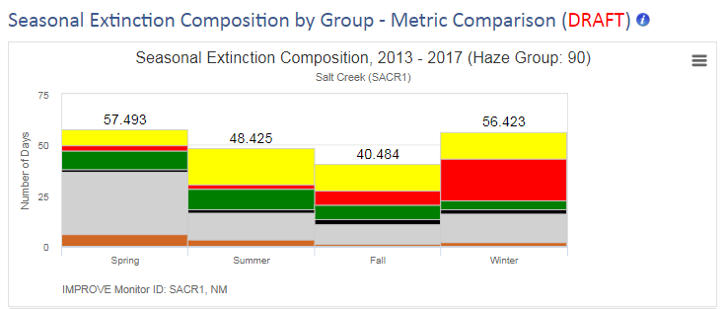 (Defining the seasons) Which months do these represent and what is most useful for SIP writers and other users.

1. Other topics?
2. **Action Items** 
   1. **Reminder to regularly check updates on TSS v2**
   2. **Please write at least one question (and answer) for the FAQ document**
3. Next call scheduled: December 13, 2018 at 10:00 am (CARB scheduled for note-taking)

|  |  |
| --- | --- |
| 11.8.2018 | ~~NV DEP~~ MT DEQ |
| (11.22.2018) | *No meeting* |
| 12.13.2018 | CARB |
| (12.27.2018) | *No meeting* |
| 1.10.2019 | NMED |
| 1.24.2019 | CABQ |
| 2.14.2019 | MT DEQ |
| 2.28.2019 | AZ DEQ |
| 3.14.2019 | NV DEP |
| 3.28.2019 | CARB |